Alexandria University
Faculty of Engineering
Computer Engineering and Systems dept.
4th year
2004-2005
Computer Communications and Networks

Token Bus Report

Submitted by:

- Mohamed Abd-ElAziz Khamis (56)

Supervisors:

Prof. Dr. M. Nazieh El-Derieni Dr. Sahar M. Ghanem
Eng. Wael M. Shaaban

Token Bus is described in the IEEE 802.4 specification and is a Local Area Network in which the stations on the bus or tree form a logical ring. They are assigned positions in an ordered sequence, with the last node in the sequence being followed by the first, as shown below. Each station knows the address of the station to its "left" and "right" in the sequence.
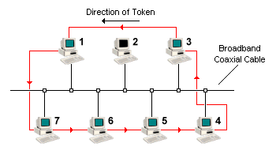
This scheme is similar to Token Ring in that a small data frame only a few bytes in size, known as a token, is used to gain network access. Token-passing networks rely on a deterministic method of accessing the network in which each node plays an active part in managing access and avoiding collisions. When a station receives the token, it is granted control of the medium for a specified time. The station may transmit one or more packets, and may poll stations and receive responses. When the station has finished with the token, or the time limit has expired, it passes the token on to the next station in the logical sequence, which takes over control of the medium. When the logical ring is initialized, the station having the highest number in the sequence has control of the token.

The physical order in which stations are connected to the cable is not important. Since the cable is essentially a broadcast medium, each station receives each frame, but discards frames that are not addressed to it. Each station sends a token that is logically addressed to the next station in the sequence, regardless of its physical location on the cable. It should be noted that when individual stations are first powered on, they are not in the logical ring (note that in the above diagram, station 2 is not in the ring). The Token Bus MAC protocol makes provisions for adding stations to the ring or deleting them from the ring as and when this is required.

The Token Bus standard was designed to meet the needs of industrial automation systems following a proposal by General Motors for a protocol for use in manufacturing plants –
Manufacturing Automation Protocol (MAP). IEEE802.3 was not considered suitable for factory automation because of the contention-based nature of its MAC protocol, which meant that stations might have to wait a long time to send a frame. The lack of a prioritization system also makes Ethernet unsuitable for real time systems in which important frames should not be held up for less urgent traffic.

Token-passing, in which each station takes turns to send a frame, was considered a better option because if there are n stations, and each station takes T seconds to send a frame, no station has to wait longer than nT seconds to send a frame. The ring topology of existing token-passing systems, however, was seen as a disadvantage, because a break in the ring meant network failure. Furthermore, a ring topology is a poor fit to the linear topology of most assembly lines. Thus, Token Bus was developed, having the robustness of the 802.3 broadcast cable, but with the known worst case behavior of a ring topology.

The transmission medium used for Token Bus networks is 75 Ohm broadband coaxial cable - the same type of cable used for cable TV, although both baseband and broadband configurations are available. Both single and dual cable systems may be used, with or without head-ends. Possible data rates are 1, 5 and 10 Mbps. The permitted analog modulation schemes are:
- phase continuous frequency shift keying
- phase coherent frequency shift keying
- multilevel duo binary amplitude modulated phase shift keying

The Token Bus MAC Layer Protocol

On initialization of the ring, tokens are inserted into it in station address order, starting with the highest. Token-passing also takes place from high address to low addresses. When a station acquires the token it has a specified amount of time in which to transmit frames, so the number of consecutive frames which can be transmitted by each station depends on the length of the frames. If a station has no frames to send, it immediately passes the token to the next station.

The Token Bus standard defines four classes of priority for traffic - 0, 2, 4, and 6 - with 6 being the highest priority and 0 being the lowest. Each station maintains four separate internal queues corresponding to the four priority levels. When a frame is passed down to the MAC sub layer from a higher protocol, its priority is checked and it is assigned to the appropriate queue. When a station receives the token, it is passed to the highest priority queue (level 6) first. If this queue does not have any frames to send, the token is passed to the next highest priority queue (level 4) and so on.

Each queue has a specified time in which to transmit frames, after which it must relinquish the token to the next queue. If the token reaches level 0 and there are no frames to be sent, the token immediately passes to the next station. This process is controlled by timers, which can be used to allocate a specified time to each queue, depending on priority. If the highest level queue has no frames to send, its allocated time can be used by the lower priority queues.

This priority scheme guarantees priority 6 traffic a known fraction of the network bandwidth, and can be used to implement real-time traffic. For example, if a network running at 10 Mbps and having 50 stations has been configured so that priority 6 traffic is allocated 1/3 of the bandwidth, each station is guaranteed 67 kbps for priority 6 traffic.

This bandwidth could be used to synchronize robots on an assembly line, or carry one digital voice channel per station with some bandwidth left over for control information.
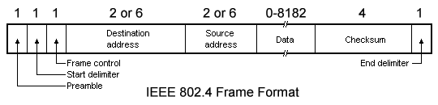

The Token Bus frame format is shown above. The Preamble is used to synchronize the receiver's clock. The Start Delimiter and End Delimiter fields are used to mark the frame boundaries. These fields contain analog encoding of symbols other than 0s and 1s, so they cannot occur accidentally in user data. Because of this, no length field is required.

The Frame Control field is used to distinguish data frames from control frames. For data frames, it includes the frame's priority. It can also include an indicator requiring that the destination station acknowledge correct or incorrect receipt of the frame. For control frames, the Frame Control field is used to specify the frame type. This includes token passing and various ring maintenance frames, including the mechanism for allowing stations to enter or leave the ring.

The Destination and Source address fields in any given network must use all 2-byte addresses or all 6-byte addresses, not a mixture on the same cable. If 2-byte addresses are used, the Data Field can be up to 8182 bytes. If 6-byte addresses are used it is limited to 8174 bytes. The Checksum is used to detect transmission errors.

The various control frames used are shown in the following table.
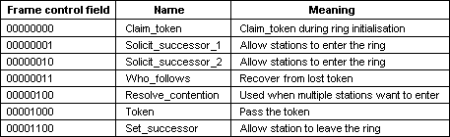

Periodically, a station will transmit a SOLIT_SUCCESSOR frame to solicit bids from stations wishing to join the ring. The frame includes the sender's address, and that of its current successor in the ring. Only stations with an address falling between these two addresses may bid to enter the ring (in order to maintain the logical order of station addresses on the ring). If no station bids to enter within a slot time, the response window is closed, and the token holder returns to its normal business. If only one station bids to enter, it is inserted into the ring and becomes the token holder's successor. If two or more stations bid to enter, their frames will collide and be garbled. The token holder then runs an arbitration starting with the broadcast of a RESOLVE_CONTENTION frame. The algorithm is a variation of binary countdown, using two bits at a time.

All station interfaces maintain two random bits which are used to delay all bids by 0, 1, 2 or 3 slot times to further reduce contention. Two stations will only collide on a bid, therefore, if the current two address bits being used are the same and they happen to have the same two random bits. To prevent stations that must wait 3 slot times from being at a permanent disadvantage, the random bits are regenerated either every time they are used, or every 50 msec.

The solicitation of new stations is not permitted to interfere with the guaranteed worst case for token rotation. Each station has a timer that is reset whenever it acquires the token. When the token arrives, the old value of this timer (i.e. the previous token rotation time) is inspected before the timer is reset. If a certain threshold value has been exceeded, there has been too much traffic recently, so no bids may be solicited this time round. In any case, only one station can enter the ring at each solicitation to limit the amount of time which can be used for ring maintenance. There is no guaranteed time limit set on how long a station has to wait to enter the ring when traffic is heavy, but in practice it is not normally longer than a few seconds.

To leave the ring, a station X with a predecessor P and a successor S simply sends a SET_SUCCESSOR frame to P telling it that from now on its successor is S. Station X then just stops transmitting.

Ring initialization is a special case of adding new stations. When the first station comes on line, it registers the fact that there is no traffic for a certain period. It then sends a CLAIM_TOKEN frame. Not hearing any other stations contending for the token, it creates a token and sets up a ring containing only itself. Periodically, it solicits bids for new stations. As new stations are powered on, they will respond and join the ring, if necessary using the contention algorithm described above. If the first two stations are powered on simultaneously, they are allowed to bid for the token using the standard modified binary countdown algorithm and the two random bits.

Problems sometimes arise with the token or the logical ring due to transmission errors (for example a station tries to pass a token to a station which has gone down). After passing the token, therefore, a station listens to see if its successor either transmits a frame or passes the token. If neither occurs, it generates a further token. If that also produces negative results, the station transmits a WHO_FOLLOWS frame specifying the address of its successor. When the failed station's successor sees a WHO_FOLLOWS frame naming its predecessor, it responds by sending a SET_SUCCESSOR frame to the station whose successor failed, naming itself as the new successor, and the failed station is removed from the ring.

If two consecutive stations have gone down, the WHO_FOLLOWS frame will obviously fail to elicit a response. In this situation, the station which originally passed the token sends a SOLICIT_SUCCESSOR_2 frame to see if any other stations are still alive. The standard connection protocol is run once again, with all stations that want to be in the ring now bidding for a place, and the ring is eventually re-established.

A problem also occurs if the token holder goes down and takes the frame with it. In this case, the ring initialization algorithm is used. Each station has a timer that is reset every time a frame appears on the network. When this timer hits a threshold value, The station issues a CLAIM_TOKEN frame, and the modified binary countdown algorithm with random bits determines who gets the token.

Multiple tokens are another problem. If a station holding the token notices a transmission from another station, it discards its token. If more than two tokens are present on the network at the same time, this process is repeated until all but one of the tokens are discarded. If all the tokens are discarded by accident, the lack of activity will cause one or more of the stations to try and claim the token.

What if a number of stations want to get into the logical ring at the same time during a response window? If a number of stations want to get into the logical ring during a response window, they will all send out the set-successor frame, there will be a collision, and the soliciting station will get a garbled message. The station holding the token senses the collision and sends out a resolve__contention frame. After this frame, the stations that want to get in on the logical ring contend for the privilege of getting into the logical ring in an orderly manner. Before describing how this contention proceeds, a characteristic of the network must be defined.
Slot time is the longest amount of time any station needs to wait for another station to respond. This delay is equal to the time it takes for a signal from the initiating station to propagate over the cable and be received by the addressed station, for the addressed station to send out a response frame, and for the response frame signal to propagate back over the cable again. In any given network, the slot time must be calculated and put into each station as a network parameter.
Signals on the cable travel at about 82% of the velocity of light. This means that a meter of cable delays a signal about 4.1 nano-seconds. The typical delay of a single station's response is about 10 micro-seconds. A network with a 500 meter long cable system would have a slot time of:
2 × (500 × 4.1 × 10⁻⁹) + 10 × 10-6 = 14 micro-seconds
Since the carrier-band network operates at 5 Mbits/second, each bit time is 0.2 microseconds and each octet time is 1.6 micro-seconds. The slot time in octets then becomes
14/1.6 = 8.75 octet times
Now back to contending for the logical ring.
During contention, all the stations that want to get into the logical ring listen for signals on the medium for 0, 1, 2, or 3 slot times. The amount of time a station waits is determined by taking the first pair of bits from its own address and determining the 0, 1, 2, or 3 slot times from that binary number. If a contending station hears no other station transmitting, then it sends a set__successor frame. This frame is one slot time long to the token holder. If a contending station hears anything during the time that it listens, that station eliminates itself from the contention. In this way, only one station gets into the logical ring every time the resolve__contention frame is sent.
If two stations have an identical first pair of bits in their addresses, then the stations will collide again. In this case, the procedure is repeated using the next pair of bits from the address. By the time all 48 bits of addresses are used, the contention is resolved, because eventually a pair of address bits for the two contending stations is different and only one station is admitted into the logical ring.
A break in the cable can occur if the following occurs:

- the cable is physically separated into two pieces
- At least one end of the cable becomes disconnected.

In either case, one or both ends of the cable are no longer terminated, causing the signal to bounce.

The computers on the network can still function as stand-alone computers. However, as long as the segment is broken, they cannot communicate with each other or access shared resources.
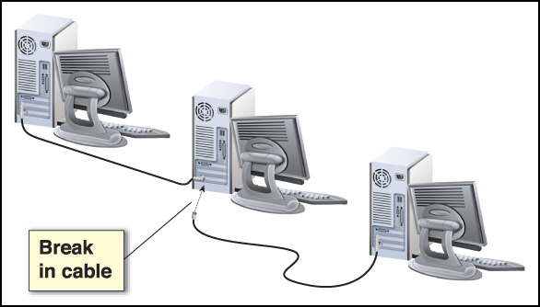

Priority
The data frames that are to be sent from a given station can be classified by their importance. The important frames can be given priority and sent first. Priority is an optional feature of any given station. Four classes of priority frames can be sent. Alarm and error messages could be assigned top priority. Real-time control messages could be the next priority file transfers the next, and periodic messages for time-of-day and other non-critical messages the last priority.

A token-holding station is allowed to send all the highest-priority frames it can within a time set by station management. When the time expires, then the token must be passed on.

For each of the lower-priority classes, a token rotation time is specified by the station management. If the actual token rotation time is less than the specified time, the station is allowed to send a priority message.

In a token bus system, the delay between when a frame is submitted for transmission and when it is actually sent can be calculated for a given system by knowing the number of stations, the size and frequency of frames that each station generates, and the priorities of the frames. When there is no load, the worst-case delay is the token rotation time. When the system is heavily loaded with the highest-priority messages, the delay is that of the token-passing time plus the time each station is allowed to send the first-priority messages.

MAC Services:

For the carrier-band modem, it was easy to identify that part of the station; the modem was a box, a board, or a chip. The part of the station that has just been described is not as easy to identify. Some of the protocol is performed by a semiconductor chip; other parts are performed by software running in a microprocessor in the station. Conceptually, we can think of a "box" within the network station that performs these protocol tasks, as shown in the following Figure.
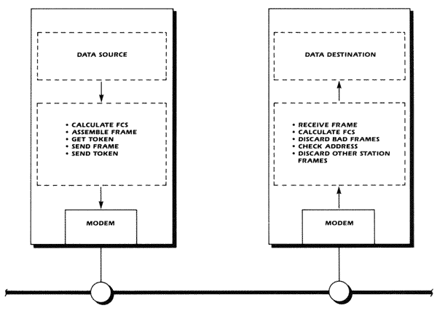
MAC Functions

In a transmitting station, the "box" gets a data block from a data source to send and then waits to get a token to gain access rights to the shared cable. If the priority is right, the "box" then sends a frame with a preamble, a start delimiter, an address field a control field, the data itself, the frame checks sequences, and then the end delimiter.

In a receiving station, the "box" recognizes addresses and examines the FCS to see if good data has been received. The "box" discards corrupted frames and passes only good data blocks to a data destination "box" in the receiving station.

All together, this part of the network station is called the Medium Access Control or MAC. MAC performs a service for other "boxes" in the station, and it utilizes the service provided by the modem.

The Retrospective Token Bus Protocol

The Retrospective Token Bus Protocol forms an Intellectual Property Product. The protocol operates on the basis of retrospectively passing a logical token over a bus topology network. The protocol is highly efficient and highly reliable - has the efficiency of a token ring network with the reliability of a bus network. It is simple and cheap to implement. Patents have been applied for and have been granted.

As the company is essentially an Intellectual Property based company it is interested in joint arrangements where financing is supplied from external sources. We can not only supply the Intellectual Property but also extensive expertise - both technically and with regards the business side.

Token Bus Protocol Number1 | The basic technology - patents the active retrospective token passing and the arbitrary unit address assignment.
Token Bus Protocol Number2 | Additional features - patents the passive retrospective token passing.
Token Bus Protocol Number3A | Strategic patent - additional features - secures virtual connections + bandwidth management.

The Retrospective Token Bus Protocol can be used for all types of networks from office and telephone networks to industrial and home networks. It is ideally suited for use in Domestic Area Networks because of it's following advantages:-

- Low cost implementation - thus providing for a commercially attractive addition to domestic devices.
- Small IC real estate - thus allowing incorporation onto single chip solutions.
- Bus topology - low cost physical medium - can use existing cabling. Also highly reliable.
- Highly efficient - the low data link overhead means that the usage of the data link speed is maximized.
- Reliability and predictability of the time usage of the communication cycle - no drop outs due to packet collisions - ensures that intensive use such as pumping Digital Video around the home is conducted reliably - without drops outs and within the time requirements.

The Retrospective Token Bus Protocol is ideally suited to Quality Of Service issues:-

- It has the features and it can be varied such that all QOS issues can be handled fully.
- It is ideally suited as the LAN end of an ATM style network. It can also be used as a general LAN protocol.

The Retrospective Token Bus Protocol versus IEEE802.4

IEEE802.4 is prospective token passing protocol. As such the token is passed explicitly from the current unit to the next logical unit. This results in a complicated and costly design. The Retrospective Token Bus Protocol, however, passes the token retrospectively - the next logical unit takes up the token rather than being explicitly passed the token. As such the Retrospective Token Bus Protocol is very easy and cheap to implement. Further because it requires very small chip space it is suited to low cost integrated applications such as would be found in domestic networks.

Minimizing Token-Bus inaccessibility through network planning and parameterizing

Local area networks have long been established as a basis for distributed systems. Continuity of service and bounded and known message delivery latency are requirements of a number of applications, which are imperfectly fulfilled by standard LANs.

One key issue with this regard is that LANs are subject to failures, namely partitions. Every single LAN displays a number of causes for partition, not all of them of physical nature: bus contention, ring collapse, token loss, etc. Since most applications can live with temporary glitches, reliable real-time operation is possible on non-replicated LANs, provided that these temporary partitions are time-bounded. These periods of inaccessibility are called to differentiate from classical partitions.

Network planning and parameterizing policies can contribute for the minimization of inaccessibility periods in ISO 8802/4 Token-Bus LANs.

